IDENTITY AND ACCESS MANAGEMENT (IAM) IN AWS

DIFFERENCE BETWEEN THE SECRET KEY & ACCESS KEY
SECRET KEY
- It is a private password used for security.
- It is used to sign requests (like proving “this is me”).
- It must be kept secret, never shared with anyone.
- It works together with the Access Key.
ACCESS KEY
- It is like a username or ID.
- It is used to identify who is making the request.
- It is safe to share in systems (but not publicly).
- It works with the Secret Key for authentication.

Note:
- Secret_key: Password
- Access_key: Username

Both are required to log in and access AWS services.

FEDERATED USER
- A federated user is someone who logs into AWS using another account (not AWS username/password).
- AWS trusts another system (like Google or your company login) to verify the user.
- The user does NOT exist as an IAM user in AWS.
- They get temporary access (limited time login).

IDEA TO UNDERSTAND
- Normal IAM User = Create account inside AWS
- Federated User = Use existing login (Google/company)

EXAMPLE
- You click on Login with Google
- Google simply verifies you
- AWS trusts Google account →so u get the aws account access

IAM TERMS
IAM terms define the process AWS uses to check identity and permissions before giving access.
- Principal → Who is making the request (user/role/service)
- Request → What the user is trying to do
- Authentication → Verify identity (Are you real?)
- Authorization → Check permission (Are you allowed?)
- Action → What operation (like S3:PutObject)
- Resource → On which service/resource (like S3 bucket)
EXAMPLE
User uploads file to S3
- Principal = User
- Action = Upload (PutObject)
- Resource = S3 Bucket
- Authentication = Login check
- Authorization = Policy check

SIMPLE TRICK TO UNDERSTAND
Imagine a security guard at a company gate:
- Principal → You (person entering the office)
- Request → “I want to enter the office”
- Authentication → Guard checks your ID card (Who are you?)
- Authorization → Guard checks permission list (Allowed or not?)
- Action → What you want to do (enter, open room, etc.)
- Resource → Office/room you want to access

IAM FEATURES
- shared access to your aws account
- Granular permissions
- multifactor authentication
- identity federation
- secure access to aws resources

MULTIFACTOR AUTHENTIFICATION
- Multi-Factor Authentication (MFA) in AWS is a security method where a user must provide two or more types of verification to log in.
- So, even if someone steals your password, they cannot log in without the second factor (OTP/device).

PRACTICAL – CROSS ACCOUNT ACCESS USING IAM ROLE
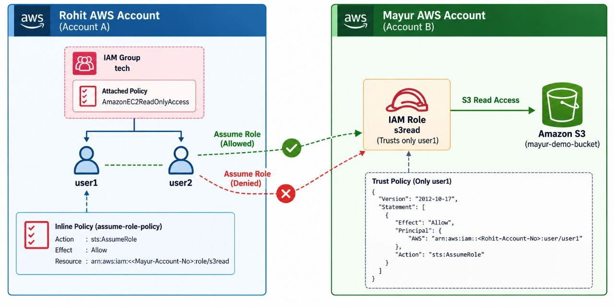
1. Login with Rohit Account
- create a group (tech)
- create two users (user1, user2) and add in group (tech)
- attach ec2-readonly access policy to a group
2. Login with Mayur Account
- create a s3 bucket (mayur-demo-bucket)
- create a role
- another aws account -----> (account no of Rohit)
- attach policy -----> S3ReadOnlyAccess -----> name (s3read)
3. Login Back to Rohit Account
- go to IAM
- click on group
- add permissions
- create Inlined policy
- select a service ----> STS
- Actions Allowed ---> AssumeRole
- Effect ----------> allow
- Resources ----> specific
- Add ARNs
- Resource -----> Other Account (mayur-account-no)
- Role_name --> s3read
- Add ARNs
- Policy-Name ----> assume-role-policy
- Create policy

4.Login with user1
- click on username
- switch role---------> (mayur account no) --------> s3read-------> switch role
- you can access the s3 bucket of mayur account
5. Login as user2
- click on username
- switch role---------> (mayur account no) --------> s3read-------> switch role
- you can access the s3 bucket of mayur account
RESTRICT ACCESS ONLY TO USER1
6. Login as Mayur Account
- click on created role(s3read)
- click on trusted relationship
- edit trusted relationship
- paste ARN of user1 (arn:aws:iam::<Rohit-Account-No>::user/user1)
- update policy

{
"Version": "2012-10-17",
"Statement": [
{
"Effect": "Allow",
"Principal": {
"AWS": "arn:aws:iam::<Rohit-Account-No>:user/user1"
},
"Action": "sts:AssumeRole",
"Condition": {}
}
]
}
7.Login as user1
- click on username
- switch role ---------> (mayur account no) --------> s3read -------> switch role
- you can access the s3 bucket of Mayur account
8. Login as user2
- click on username
- switch role ---------> (mayur account no) --------> s3read -------> switch role
- you get a api error because user2 arn not be included in mayur account role.

AWS IAM BEST PRACTICES
- avoid using root account except of account setup.
- add user to group and assign permission to group.
- use password policy or MFA
- use access keys for CLI & SGK
- never share ACCESS KEYS or password on any platform.
- audit the permission using IAM credential report.

